UI Convention

1. Git Convention

1.1 Git Configure
Please use the following configure for Stratus UI project:
git config --global user.name Stratus-UI-Implementation
git config --global user.email Stratus-UI-Implementation@augmentum.com

1.2 Git Workflow
Please refer to document \\192.168.1.19\Development\Stratus\Documents\Git how to\Git how to for Stratus.doc to know the git workflow for stratus projects.

1.3 Branch Name Pattern
For implementing tasks, use pattern like “TK-09527” to name branch.
For fixing bugs, please follow the following pattern:
  - If the bug need more than 4 hours to fix based on your estimation, please contact UI leader to create a dedicated task for it.
  - If the bug can be fixed in 4 hours, use the pattern like “TK-01314-SC100”. (TK-01314 refers to task id for fixing bug, SC100 refers to bug id in JIRA.)

1.4 Comment Pattern
For task branch, use the pattern like “TK-09527 Task description”.
For bug fixing branch, use the pattern like “TK-01314 Bug fixing | Bug#SC100 Bug description”. By doing so, JIRA can relate each commit with related bug.

1.5 Use TortoiseMerge as git merge tool
Tortoise is the visual merge tool of TortoiseSVN, which has been installed.
Please follow the following steps to use merge tool to replace the manual merge:
  - Add the “C:\Program Files\TortoiseSVN\bin” to OS system path
  - Add the following config to “C:\Documents and Settings\{your name}\.gitconfig”:
[diff]
tool = tortoise
[difftool "tortoise"]
cmd = TortoiseMerge -base:\"$LOCAL\" -theirs:\"$REMOTE\"
[difftool]
prompt = false
[merge]
tool = tortoise
[mergetool "tortoise"]
cmd = TortoiseMerge -base:\"$BASE\" -theirs :\"$REMOTE\" -mine:\"$LOCAL\" -merged:\"$MERGED\"
[mergetool]
prompt = true
To use TortoiseMerge to deal with conflicts by “git mergetool”, execute the following command:
git config --global merge.tool tortoisemerge
git config --global mergetool.tortoisemerge.path "C:\Program Files\TortoiseSVN\bin\TortoiseMerge.exe"
git config --global mergetool.prompt false

2. Workspace Configuration

2.1 General Configuration
a. General text file encoding:
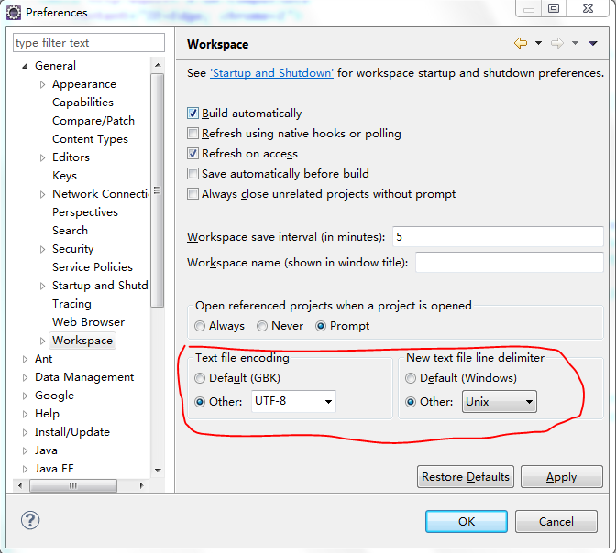
general-encoding.png

b. General text editor configuration:
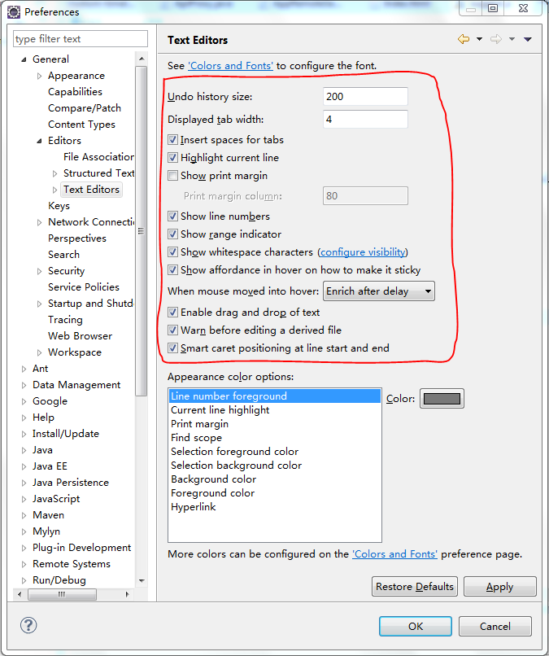
general-text-editor.png

2.2 Java Configuration
a. Java code style formatter – Indentation:

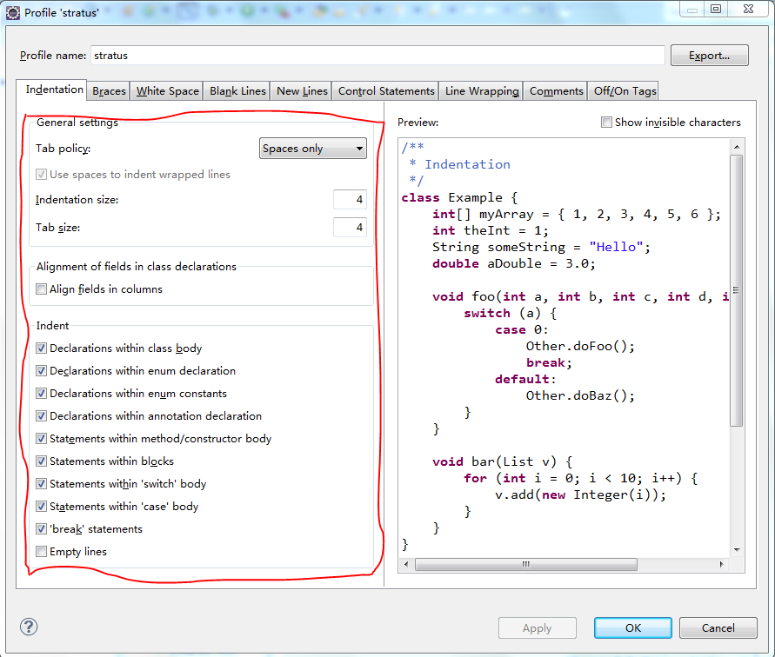
java-code-style-indentation.png

b. Java code style formatter – Line Wrapping:
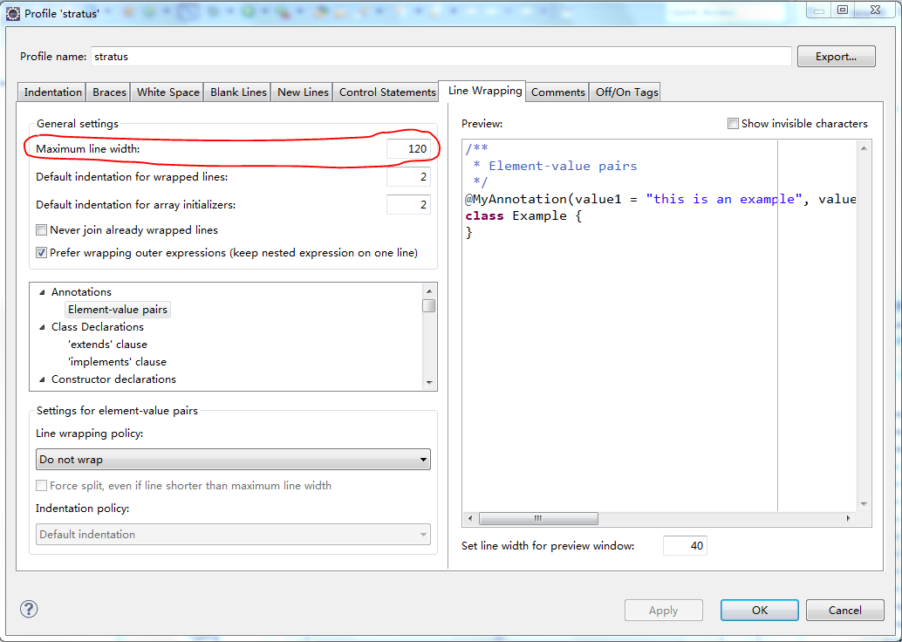
java-code-style-line-wrapping.png

c. Java code style formatter – Comments:
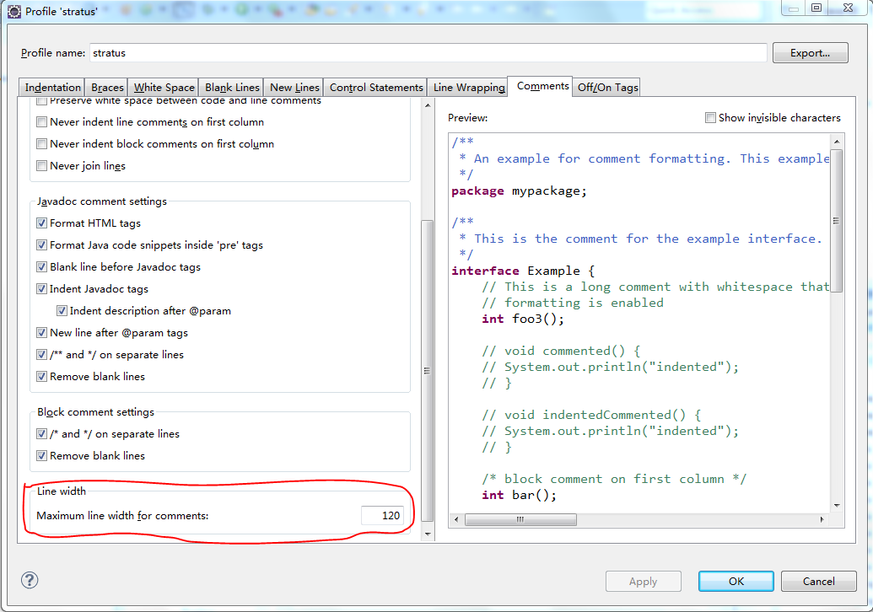
java-code-style-comments.png
d. Java editor save actions:
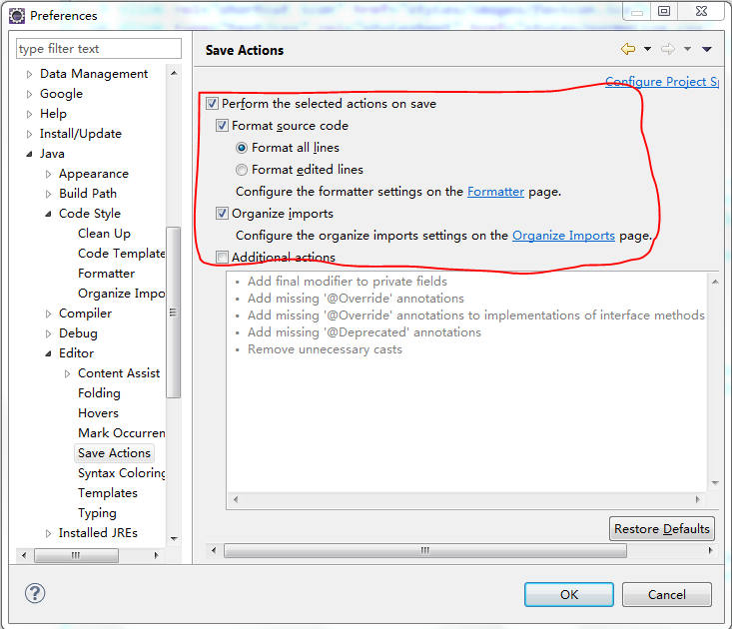
java-editor-save-actions.png
Note: Configuration for java code style formatter has been exported as \\192.168.1.19\Development\Stratus\Documents\UI Implementation\codestyle\stratus-ui-java.xml, you can just import it as follows:
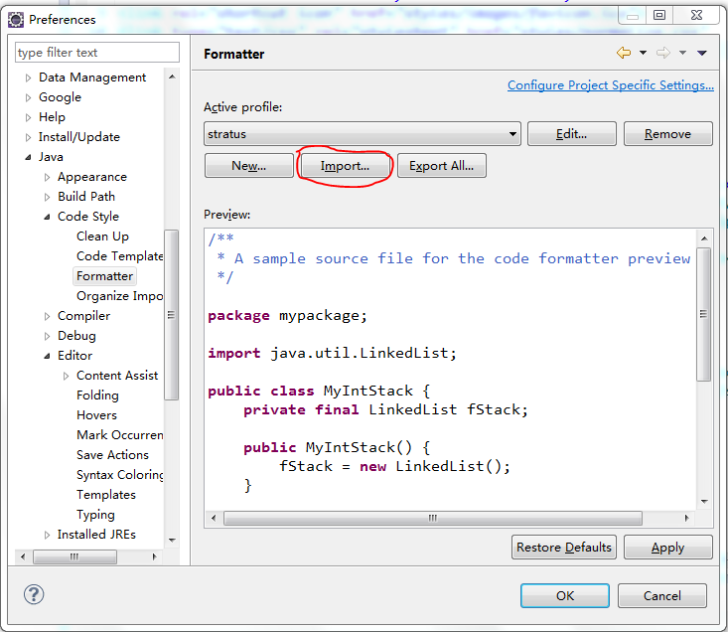
import-java-formatter.png

2.3 Javascript Configuration
a. Javascript code style formatter – Indentation:
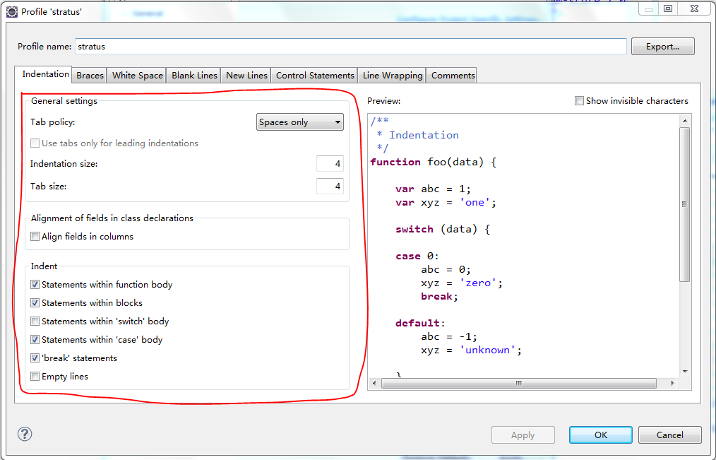
javascript-code-style-indentation.png

b. Javascript code style formatter – Line Wrapping
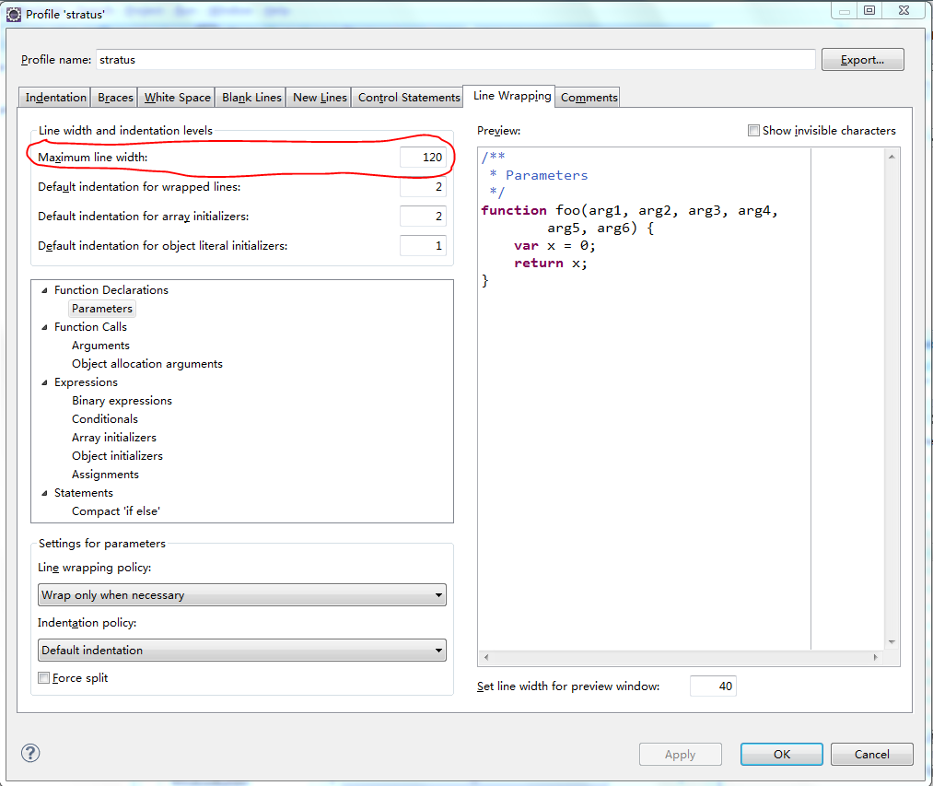
javascript-code-style-line-wrapping.png
c. Javascript code style formatter – Comments:
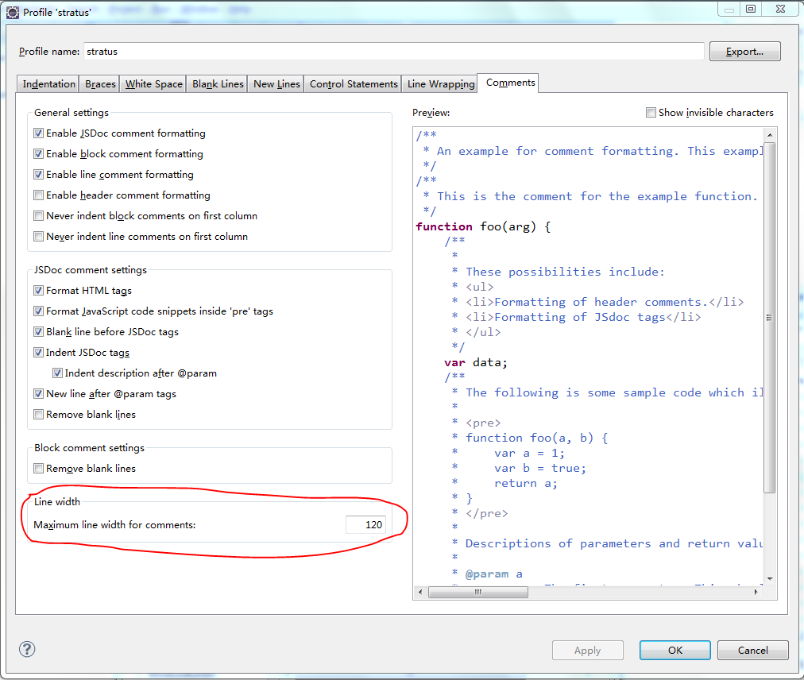
javascript-code-style-comments.png
Note: Configuration for javascript code style formatter has been exported as \\192.168.1.19\Development\Stratus\Documents\UI Implementation\codestyle\stratus-ui-js.xml, you can just import it as follows:
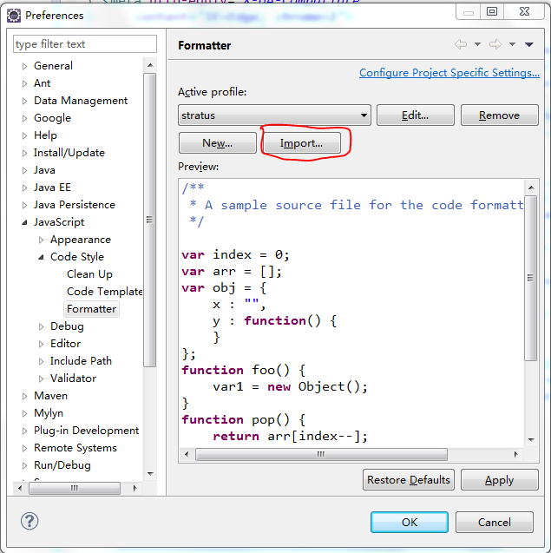
import-javascript-formatter.png

2.4 CSS, HTML, XML Configuration
a. CSS file editor:
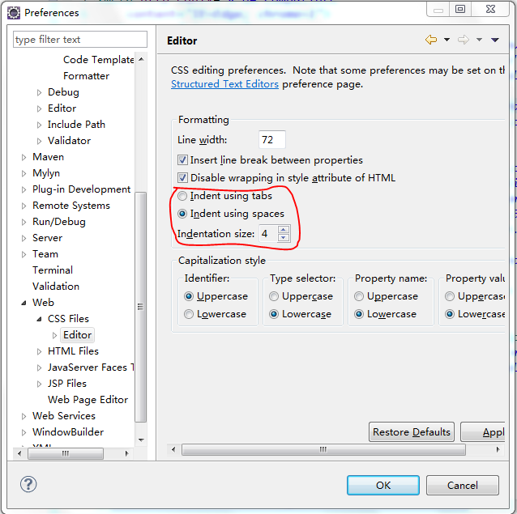
css-file-editor.png
b. HTML file editor:
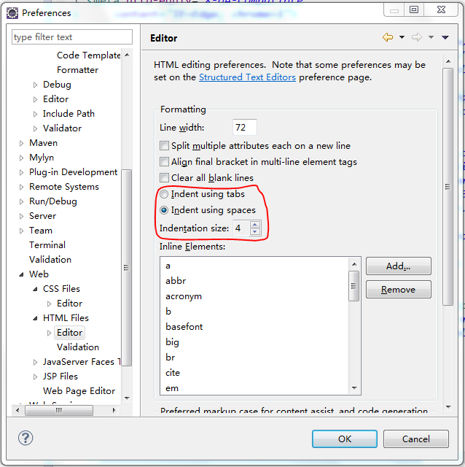
html-file-editor.png
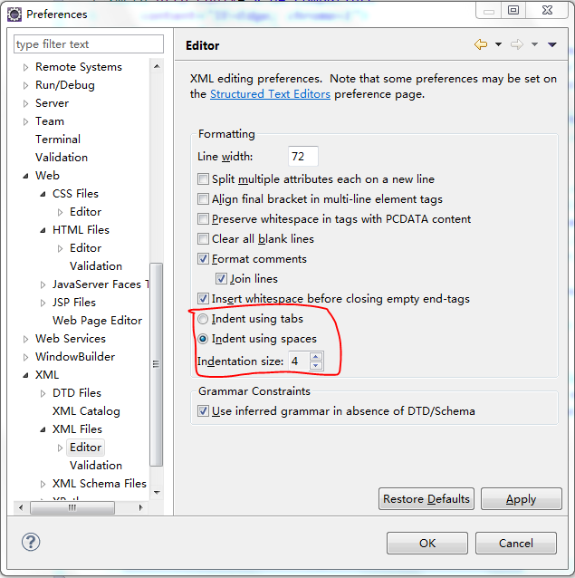
c. XML file editor:
xml-file-editor.png

